Cavendish Community Primary School



Cavendish Road

West Didsbury
Manchester M20 1JG

Tel: 0161 445 1815

Email: office@cavendish.manchester.sch.uk
Website: www.cavendish.manchester.sch.uk

Headteacher: Mrs. Jo Taylor Deputy Headteacher: Mr. David Griffiths

Assistant Headteachers: Mr. Elliot Mepham, Mrs. Gill Day, Mrs. Clare Powell, Ms Helen Devine,
School Business Manager: Ms Nic Kennedy

Free School Meal (FSM) Checking form – PLEASE COMPLETE BOTH SIDES.

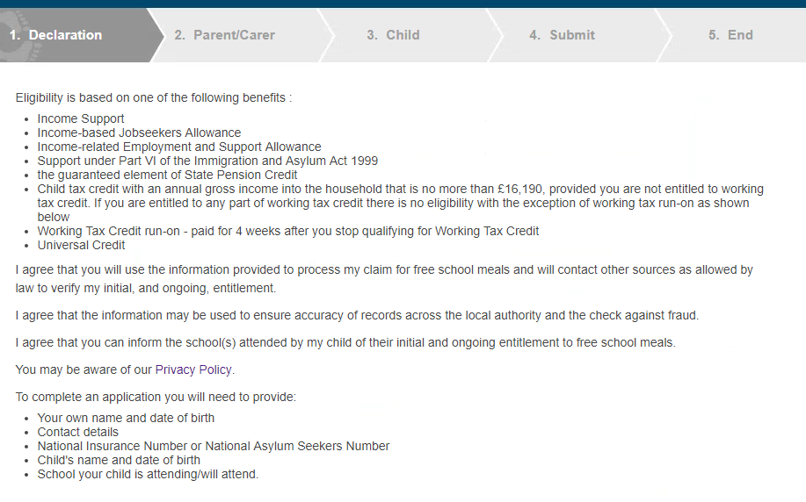

Parent/Carer Legal Declaration

I ________________________ am the parent/carer of: ____________________ Child’s D.O.B____________

Parent/Carer NI Number ___________________ Parent/Carer D.O.B ________________

I give permission for Cavendish Community Primary School to check my eligibility for free school meals.

Signature__________________________
Note: The information provided will only be used by the school for the checking of eligibility for Free School Meals, it may only be shared with parties listed above. Please complete the details on the back of the form to enable us to process your application.

Your Title: (Mr, Mrs, Ms, Dr etc.) _______________________

Your First name: _____________________________________

Your Last name: _____________________________________

Your Date of Birth: ____/____/____

Your National Insurance Number: _______________________

OR

Your National Asylum Support Service reference number: _______________________

Relationship to the child: (Mother, Father etc.) _______________________

E-mail address: _____________________________________

Telephone number: _____________________________________

Address: _____________________________________

_____________________________________

_____________________________________

_____________________________________

Postcode: _____________________________________

1st – Child’s Name: _____________________________________

1st – Child’s Date of Birth: _____________________________________

2nd – Child’s Name: _____________________________________

2nd- Child’s Date of Birth: _____________________________________

3rd – Child’s Name: _____________________________________

3rd – Child’s Date of Birth: _____________________________________

